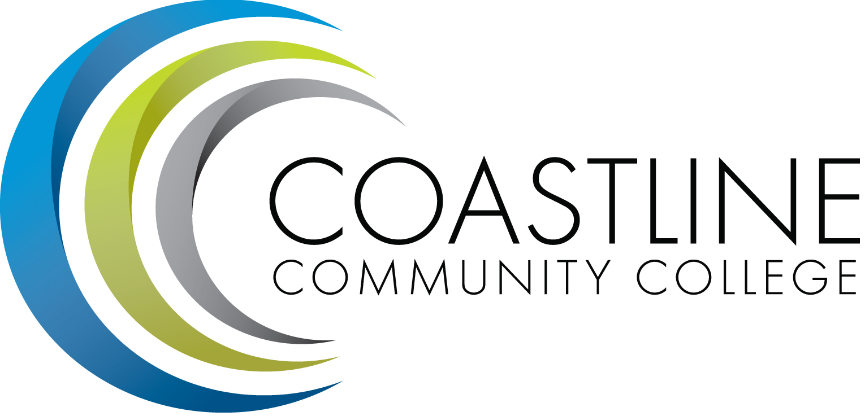
Planning, Institutional Effectiveness, and Accreditation Committee (PIEAC)
March 23, 2016
1:30 p.m. to 3:30 p.m.
Fourth Floor Conference Room

- CALL TO ORDER
  - Roll Call
  - Welcome
  - Adoption of Agenda
  - Approval of Minutes: March 2, 2016

- DISCUSSION ITEMS
2.1 Committee Evaluation A. Zentner
2.2 Educational Master Plan Objective Development Team A. Zentner
2.3 Wing Prioritizations A. Zentner

5. STANDING REPORTS
5.1 Accreditation V. Rodriguez
5.2 Budget Committee R. Lockwood
5.3 Program Review A. Zentner
5.4 Grants D. Aistrich
5.5 President’s Report L. Adrian
5.6 Wing Reports V. Rodriguez, C. Nguyen, R. Miyashiro
5.7 College Council V. Rodriguez
5.8 Facilities C. Nguyen
5.9 Contract Education J. Groot
5.10 Student Success Committee D. Pittaway
5.11 Other Committees Committee

6. ANNOUNCEMENTS (1-2 minutes per)

6. ADJOURNMENT

